**DBMS MINI PROJECT**

**CHIRAG KHANDELIA(RA1911029010036)**

**ADITYA DAS(RA1911029010038)**

**JAIWANT SINGH RAGHAV(RA1911029010040)**

**CSE-CN(P1)**

**PHARMACY MANAGEMENT SYSTEM**

**ABSTRACT**

Pharmacists can use the Pharmacy Management System program to help them methodically manage their pharmacies. When a medicine’s name is input, the Pharmacy Management System can help by providing details about the medicine. A computer displays information about the medicine, such as its dosage and expiration date. In large medical stores, manually handling the specifics of all the drugs becomes very tough. We can keep track of all the medicines by using this pharmacy management system. It is updated with new information as new medicines are introduced, and it includes an expiration date as well as a search option. When we complete the name of a medicine, it displays the medicine’s details.

**INTRODUCTION**

Pharmacy Management System is a system that organizes and manages the drug use process in pharmacies by storing data and enabling functionality. To supervise and manage the pharmacy employees in order to ensure healthy working relationships and outcomes. This is done by creating a database of the available medicines in the shop. The primary aim of pharmacy management system is to improve accuracy and enhance safety and efficiency in the pharmaceutical store. The system allows the user to enter a manufacturing and expiry date for a particular product or drug during opening stock and sales transaction. The software can print invoices, bills, receipts etc. It can also maintain the record of supplies sent in by the supplier. The system will also give report showing the list of products expiry. It is the user friendly application for Pharmacist which reduces the burden and helps to manage all sections of Pharmacy like Medicine management and Billing etc.

**PROBLEM INTRODUCTION**

**Problem Statement:** Most pharmacies faced problems such as insufficient service promotions, lack of coherence of pharmacy services in hospitals, poor drug information systems, and the inconsistency of the pharmacy information management due to its manual processes.

**Scope:** One of the most important responsibilities of pharmacy management is to supervise and manage the pharmacy employees to ensure healthy working relationships and outcomes. Each of these functions is critical to the pharmacy’s operation and should be improved.

**PROPOSED SOLUTION**

Pharmacy Management System Project is a great system for storing data, maintaining, and organizing the use and process of medications in the pharmacy. This computer software is programmed to perform the various tasks required in the operation of a pharmacy. The system will improve the efficiency of the pharmacy and enable the storing of digital records. Managing a system for pharmacy is the process of creating and implementing evidence-based pharmaceutical usage strategies to improve member and population health while maximizing healthcare resources.

**MODULE USED**

* **Medicine Management:** To manage medicines modules will assess the need for and use of medication, the patient’s response to medication, and the patient’s level of understanding of the drug and how to take it with the patient.
* **Categorize Medicine Information:** Categorizing the drugs available in the pharmacy will be much easier for the admin through the help of this module. This will do the monitoring and checking of the medicine information to identify its category.
* **Monitor Medicine Orders:** is used to keep track of dates and events throughout the process chain, from placing an order with an external vendor to presenting goods in a store or receiving goods in a distribution center.
* **Manage Sales and Stocks:** This module will help the Pharmacist with the sales and stocks management that includes ordering, storing, tracking, and monitoring stock levels as well as monitoring their revenue.
* **Drug Inventory Management:** The drug inventory management module strives to reduce procurement and carrying expenses while maintaining a sufficient stock of products to meet the needs of customers and prescribers. This will also monitor the performance of the pharmacy and to know what are the most needed medicines.
* **Generate Processes Reports:** In all organization or business, reports are very essential. To help the admin in these matters, this module generates the transaction reports to keep track of the pharmacy activities.

**SYSTEM DESIGN**

ER DIAGRAM

CODE SNIPPET:

-- phpMyAdmin SQL Dump

-- version 5.0.2

-- https://www.phpmyadmin.net/

--

-- Host: 127.0.0.1

-- Generation Time: Oct 25, 2020 at 12:01 AM

-- Server version: 10.4.14-MariaDB

-- PHP Version: 7.2.33

SET SQL_MODE = "NO_AUTO_VALUE_ON_ZERO";

START TRANSACTION;

SET time_zone = "+00:00";

/*!40101 SET @OLD_CHARACTER_SET_CLIENT=@@CHARACTER_SET_CLIENT */;

/*!40101 SET @OLD_CHARACTER_SET_RESULTS=@@CHARACTER_SET_RESULTS */;

/*!40101 SET @OLD_COLLATION_CONNECTION=@@COLLATION_CONNECTION */;

/*!40101 SET NAMES utf8mb4 */;

--

-- Database: `pms`

--

-- --------------------------------------------------------

--

-- Table structure for table `admins`

--

CREATE TABLE `admins` (

`id` int(11) NOT NULL,

`fname` varchar(100) NOT NULL,

`lname` varchar(100) NOT NULL,

`email` varchar(100) NOT NULL,

`phone` varchar(100) NOT NULL,

`password` varchar(100) NOT NULL,

`role` varchar(100) NOT NULL DEFAULT 'admin',

`avatar` varchar(255) NOT NULL DEFAULT 'avatar.png'

) ENGINE=InnoDB DEFAULT CHARSET=utf8;

--

-- Dumping data for table `admins`

--

INSERT INTO `admins` (`id`, `fname`, `lname`, `email`, `phone`, `password`, `role`, `avatar`) VALUES

(2, 'Admin', 'admin', 'admin@admin.com', '1704307608', '$2y$10$Gm8rjHKAIWKqJszM77XA2.1KgGHgDQap.hqcVb8DmITigFHe7IHTa', 'admin', 'images.png');

-- --------------------------------------------------------

--

-- Table structure for table `managers`

--

CREATE TABLE `managers` (

`id` int(11) NOT NULL,

`fname` varchar(100) NOT NULL,

`lname` varchar(100) NOT NULL,

`email` varchar(100) NOT NULL,

`phone` varchar(100) NOT NULL,

`password` varchar(100) NOT NULL,

`role` varchar(100) NOT NULL DEFAULT 'manager',

`avatar` varchar(255) NOT NULL DEFAULT 'avatar.png'

) ENGINE=InnoDB DEFAULT CHARSET=utf8;

--

-- Dumping data for table `managers`

--

INSERT INTO `managers` (`id`, `fname`, `lname`, `email`, `phone`, `password`, `role`, `avatar`) VALUES

(6, 'John', 'Sina', 'john@sina.com', '01700000000', '$2y$10$q47GJObI5t2mQ1CNwbmFyOlqDC/yKkxFRv4XOxryuhZvKeMhhxc7.', 'manager', 'avatar.png'),

(7, 'Brock', 'Lesnar', 'brock@lesnar.com', '01700000000', '$2y$10$7l2gCp07viznC2PyWouDeuKB85JuxOtHUYmMt8Fs.8LDa7RZBEaRW', 'manager', 'avatar.png');

-- --------------------------------------------------------

--

-- Table structure for table `pharmacists`

--

CREATE TABLE `pharmacists` (

`id` int(11) NOT NULL,

`fname` varchar(100) NOT NULL,

`lname` varchar(100) NOT NULL,

`email` varchar(100) NOT NULL,

`phone` varchar(100) NOT NULL,

`password` varchar(100) NOT NULL,

`role` varchar(100) NOT NULL DEFAULT 'pharmacist',

`avatar` varchar(255) NOT NULL DEFAULT 'avatar.png'

) ENGINE=InnoDB DEFAULT CHARSET=utf8;

--

-- Dumping data for table `pharmacists`

--

INSERT INTO `pharmacists` (`id`, `fname`, `lname`, `email`, `phone`, `password`, `role`, `avatar`) VALUES

(7, 'Pharmacist', 'Two', 'pharmacist@two.com', '01700000000', '$2y$10$5pi1bPBuaQt4s83hGFcTH.eRZvFqsMDDN.onp6.HJENwo0jqJqKjq', 'pharmacist', 'avatar.png'),

(8, 'Pharmacist', 'Three', 'pharmacist@three.com', '0170000000', '$2y$10$RqNzWY0cxl9UCf01J.N9LOTTPb7GKarWAwM7/i8T8koNoFqQQk1Li', 'pharmacist', 'avatar.png'),

(9, 'Pharmacist', 'Four', 'pharmacist@four.com', '01700000000', '$2y$10$GVggPVg5obYkaX87nzDA/u7uyMA.ej4A96RNXtLXpFWeENLxed.T6', 'pharmacist', 'avatar.png'),

(10, 'Pharmacist', 'Five', 'pharmacist@five.com', '01700000000', '$2y$10$It21v0CAlfE8vMM4BN2hIukLIiR/RFBWvRdN3PirzkW6.r28Ls0AW', 'pharmacist', 'avatar.png');

-- --------------------------------------------------------

--

-- Table structure for table `salesmans`

--

CREATE TABLE `salesmans` (

`id` int(11) NOT NULL,

`fname` varchar(100) NOT NULL,

`lname` varchar(100) NOT NULL,

`email` varchar(100) NOT NULL,

`phone` varchar(100) NOT NULL,

`password` varchar(100) NOT NULL,

`role` varchar(100) NOT NULL DEFAULT 'salesman',

`avatar` varchar(255) NOT NULL DEFAULT 'avatar.png'

) ENGINE=InnoDB DEFAULT CHARSET=utf8;

--

-- Dumping data for table `salesmans`

--

INSERT INTO `salesmans` (`id`, `fname`, `lname`, `email`, `phone`, `password`, `role`, `avatar`) VALUES

(9, 'Salesman', 'One', 'salesman@one.com', '01700000000', '$2y$10$QcBETp.yv7xnE2gtnGKN2eQiwCW4jwobEPoOBGK/qQ3knrW4OsEdG', 'salesman', 'avatar.png');

--

-- Indexes for dumped tables

--

--

-- Indexes for table `admins`

--

ALTER TABLE `admins`

ADD PRIMARY KEY (`id`);

--

-- Indexes for table `managers`

--

ALTER TABLE `managers`

ADD PRIMARY KEY (`id`),

ADD UNIQUE KEY `email` (`email`);

--

-- Indexes for table `pharmacists`

--

ALTER TABLE `pharmacists`

ADD PRIMARY KEY (`id`),

ADD UNIQUE KEY `email` (`email`);

--

-- Indexes for table `salesmans`

--

ALTER TABLE `salesmans`

ADD PRIMARY KEY (`id`),

ADD UNIQUE KEY `email` (`email`);

--

-- AUTO_INCREMENT for dumped tables

--

--

-- AUTO_INCREMENT for table `admins`

--

ALTER TABLE `admins`

MODIFY `id` int(11) NOT NULL AUTO_INCREMENT, AUTO_INCREMENT=3;

--

-- AUTO_INCREMENT for table `managers`

--

ALTER TABLE `managers`

MODIFY `id` int(11) NOT NULL AUTO_INCREMENT, AUTO_INCREMENT=8;

--

-- AUTO_INCREMENT for table `pharmacists`

--

ALTER TABLE `pharmacists`

MODIFY `id` int(11) NOT NULL AUTO_INCREMENT, AUTO_INCREMENT=11;

--

-- AUTO_INCREMENT for table `salesmans`

--

ALTER TABLE `salesmans`

MODIFY `id` int(11) NOT NULL AUTO_INCREMENT, AUTO_INCREMENT=10;

COMMIT;

/*!40101 SET CHARACTER_SET_CLIENT=@OLD_CHARACTER_SET_CLIENT */;

/*!40101 SET CHARACTER_SET_RESULTS=@OLD_CHARACTER_SET_RESULTS */;

/*!40101 SET COLLATION_CONNECTION=@OLD_COLLATION_CONNECTION */;

**SCREENSHOT**

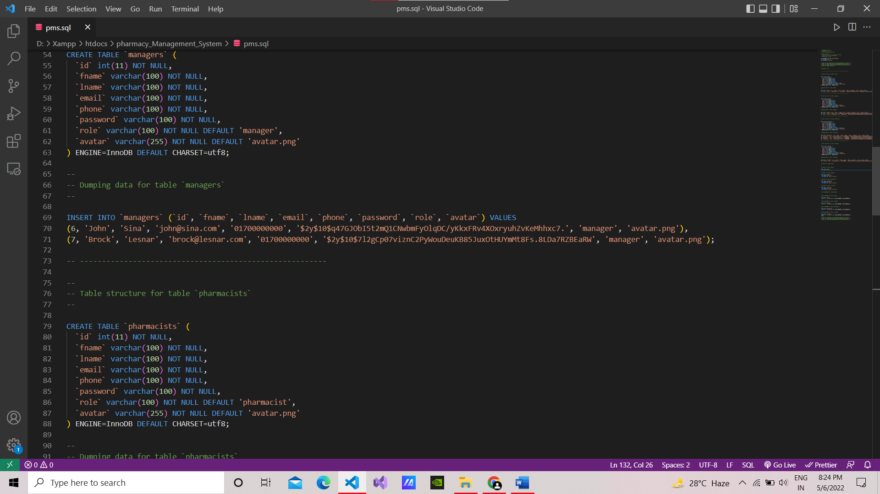

**FRONTEND**

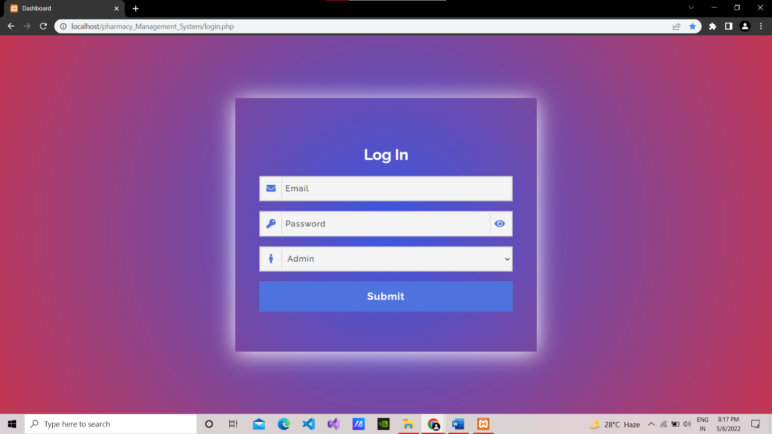

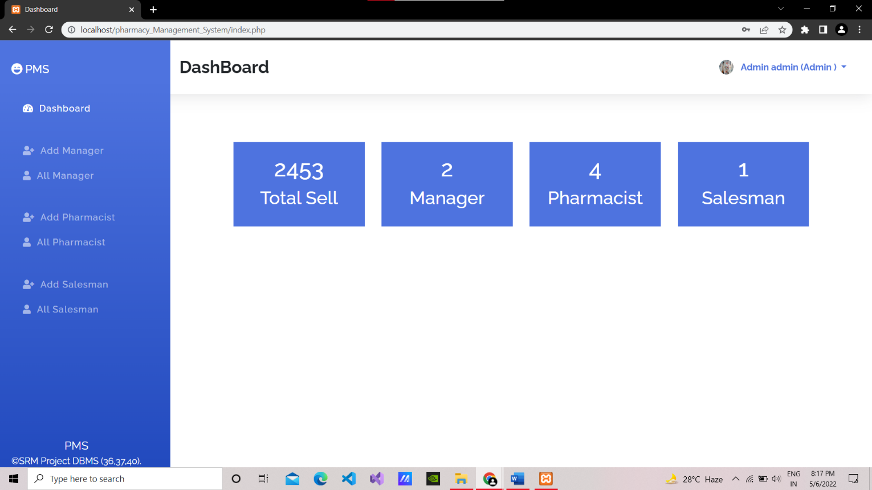

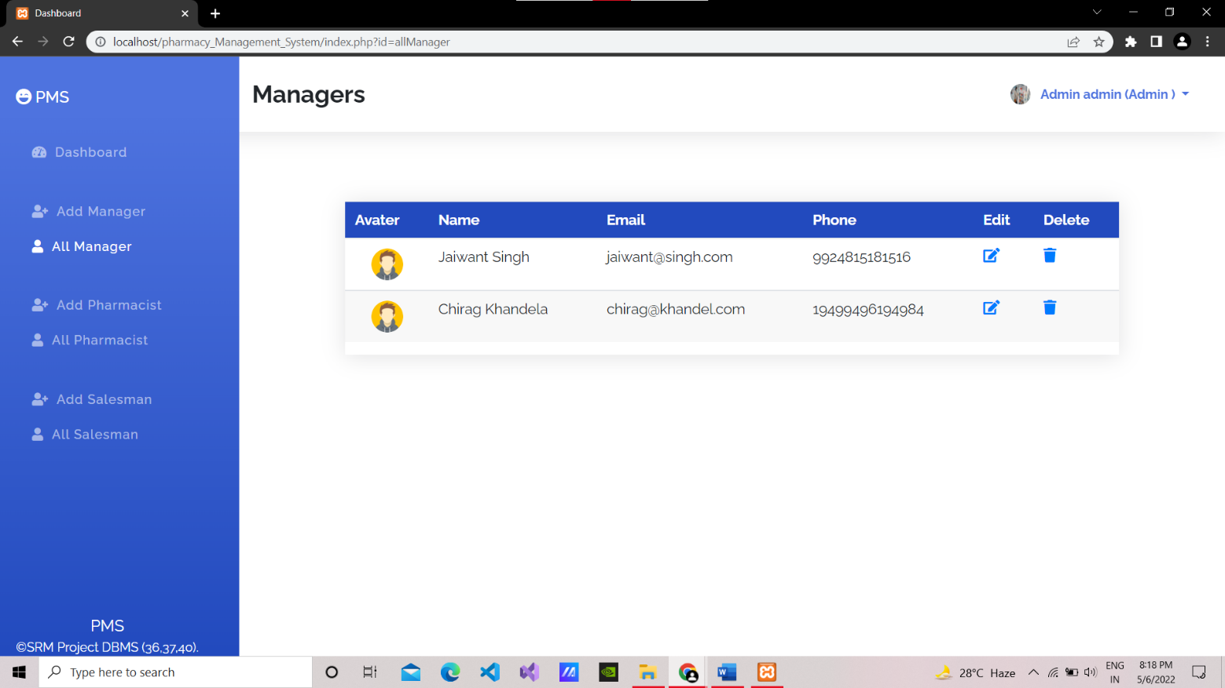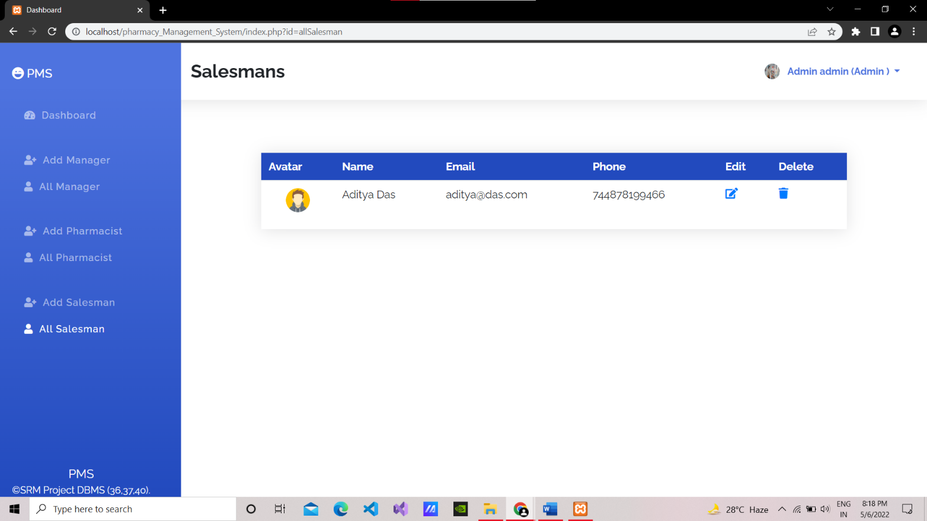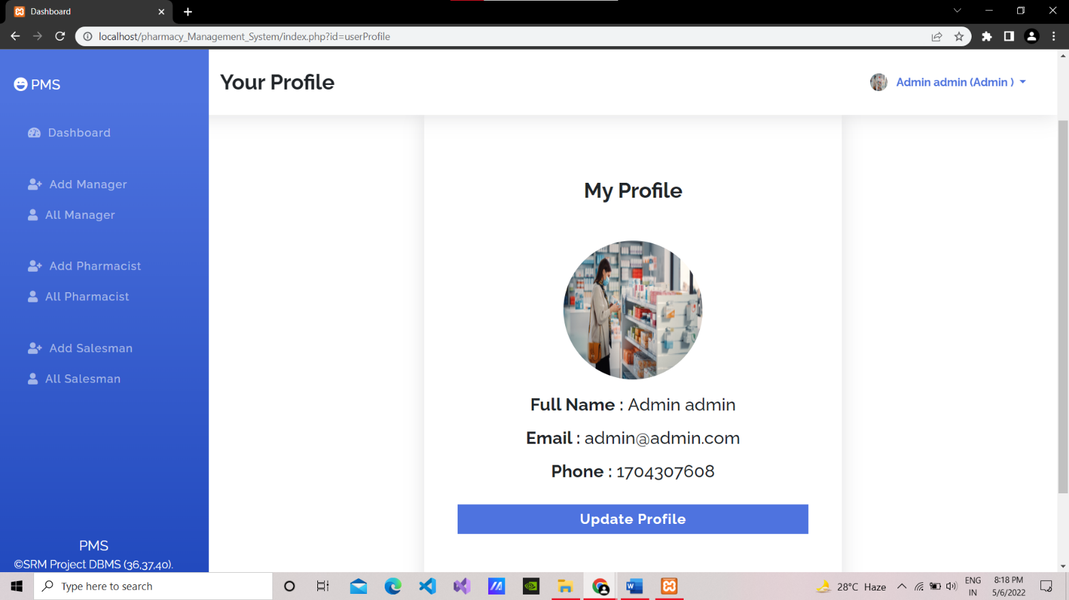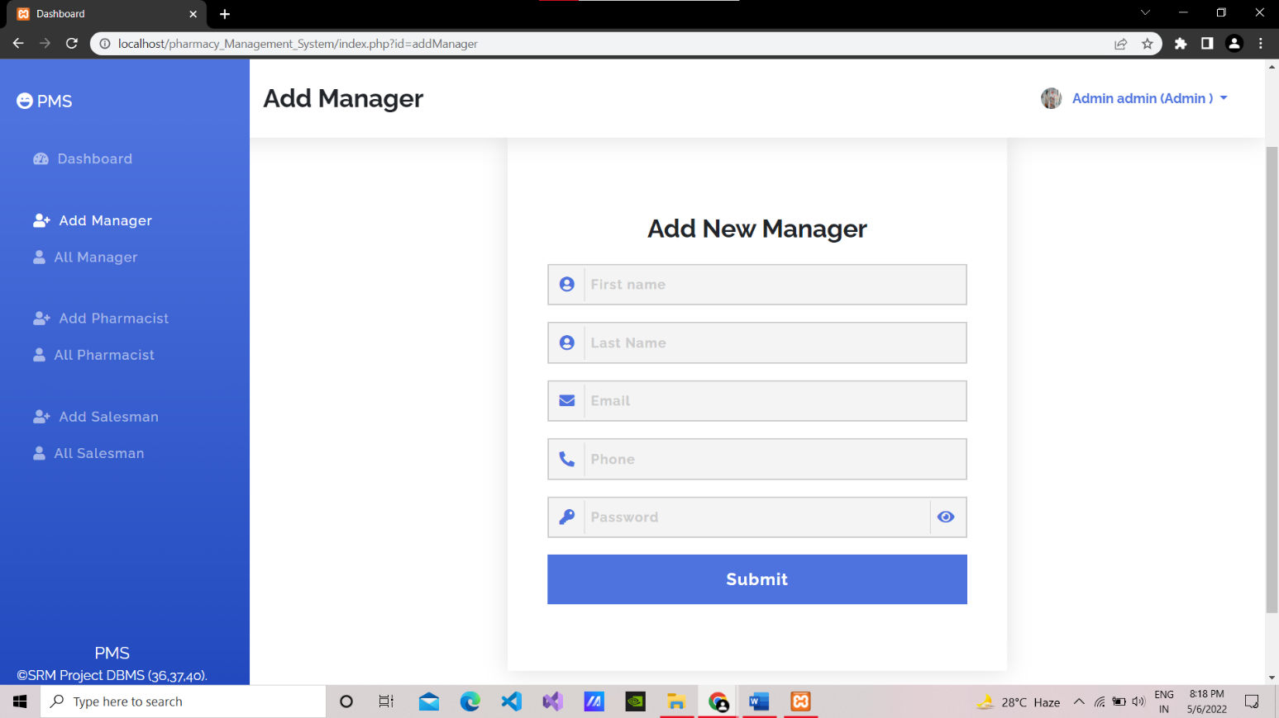

**BACKEND**

**CONCLUSION**

Therefore, we have successfully bulit a useful website for management of pharmacy in a better way.